**Decision Rules: These rules used to evaluate conditions & return required results**

**Decision Table: Multiple if Conditions ( if & else if) ( AND Logic)**

**Decision Tree: Multiple if Condition  ( if & Nested if)  ( OR Logic)**

**Map Value ( Matrix Condition- Max 2 properties we can map)**

**When ( one if Condition)**

**----**

**Decision Rules we can call in diff ways:**

**Flow: using Decision shape  ( 2 to 3 conditions we can call in flow)**

**Activity: Methods   ( If we have conditions then decision rules we have to call in activity)**

**Declare Expressions: Functions ( If any conditions defined on Data Class Properties then call in Declare Expression)**

**Decision Tree: Decision Rules we can call only in Decision Tree**

**=====**

**Declare Onchange:  On Change of Property Value , we can execute Onchange Activity rule with an optional when condition.**

**About Decision table:**

* **Any Decision Rule used to Test or Evaluate the Conditions & return required Results.**
* **In Decision Table we can add Multiple If Conditions ( 1st Condition if & From 2nd Condition we will add elseIf)**
* **All conditions are in format of If & Elseif & OtherWise**
* **If Decision Table b/w if conditions AND Logic will apply by default.**
* **In Decision Table we can use Expression Builder.**
* **Decision Tables are also called as Static Tables.**
* **We can Call Decision table in Flow  ( Decision Shape), Activity ( Property Map Decision table), Declare Expressions ( Result of Decision Table) & In Decision Tree**

**Ex:**

**If Cond1   -- Result**

**Elseif Cond2-- Result**

**ElseIf Cond3 -- Result**

**ElseIf Cond4 -- Result**

**Otherwise-----Result**

**===========**

**Req: Auto Fill Agency Name based on Agency Code**

**Decision Table-> Activity -> Declare Onchange**

**Complete requirement using Decision table & Declare Onchange Rules.**

**Add Decision table:**

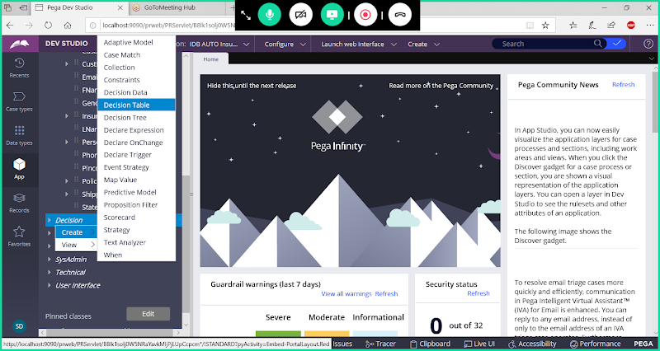

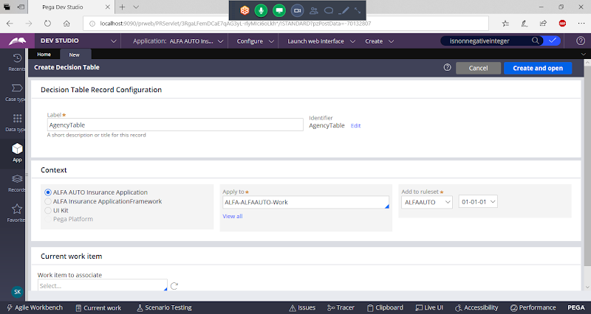

**Open**

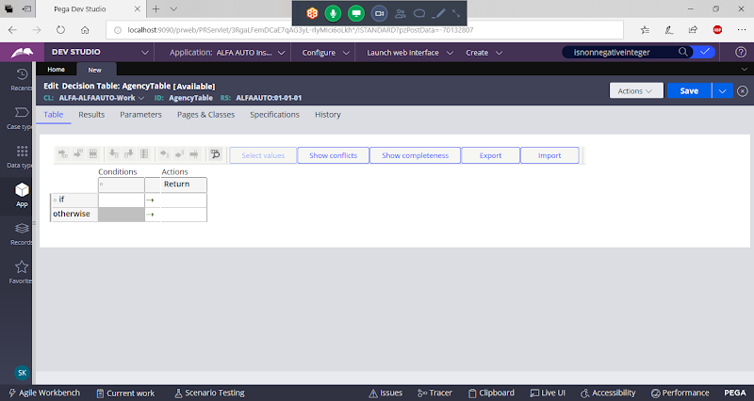

**Click on Conditions column to Add Property:**

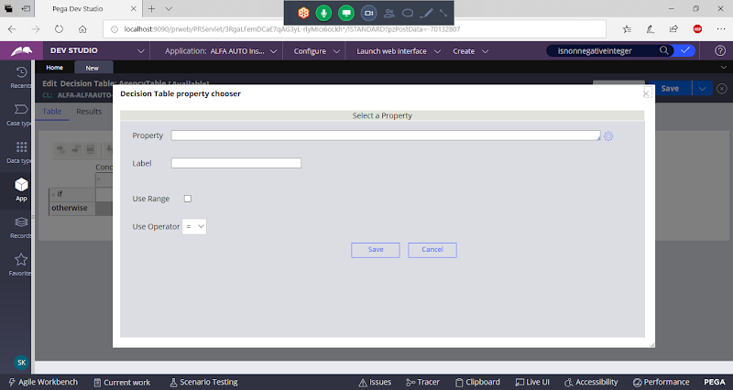

**Add Agency Code Property**

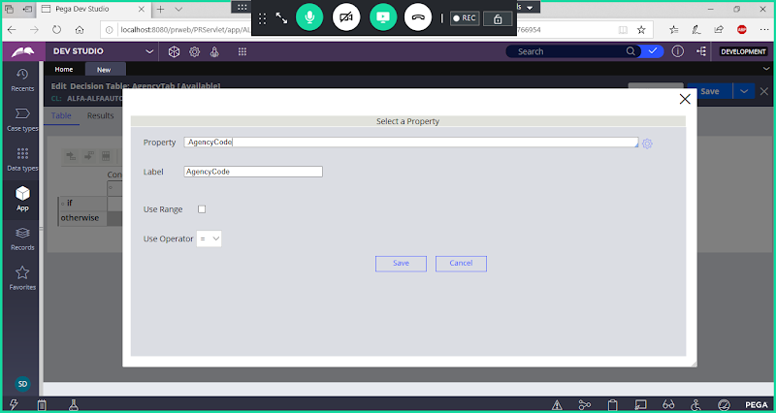

**Click on save**

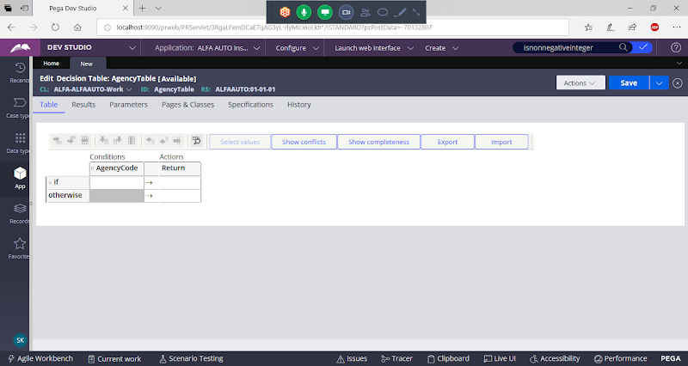

**Add Rows**

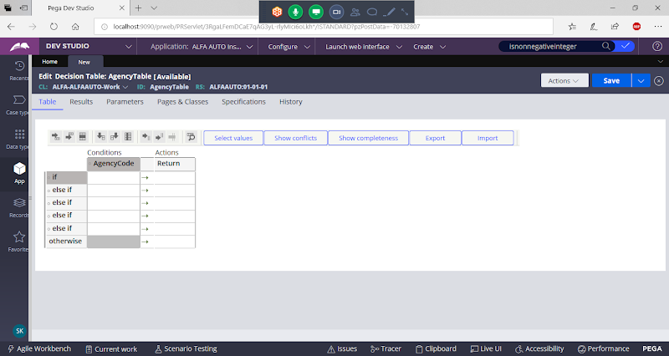

**Manually Add some Agency Codes & Return some Results**

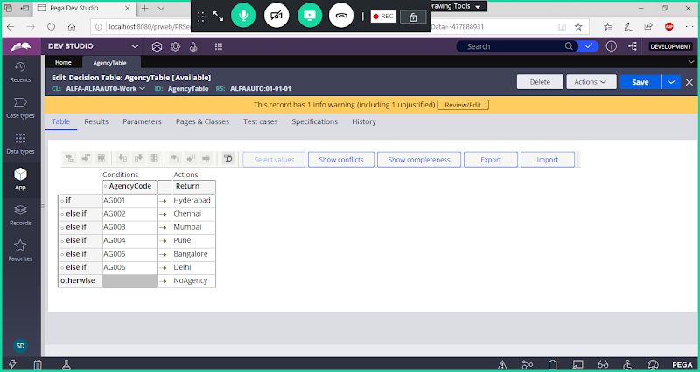

**Save Decision table**

**Call Decision Table in Onchange Activity ( Method: Property Map Decision table)**

**Create Activity:**

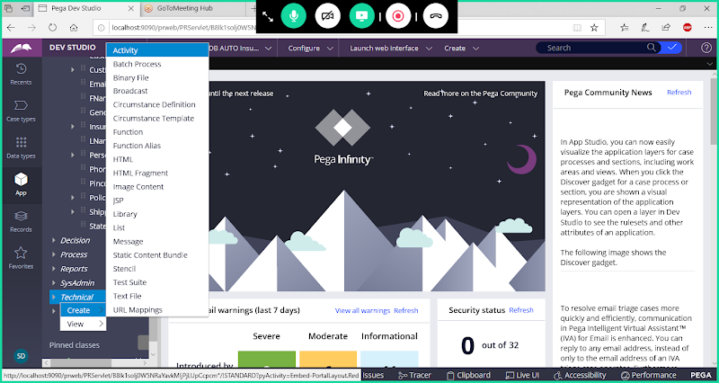

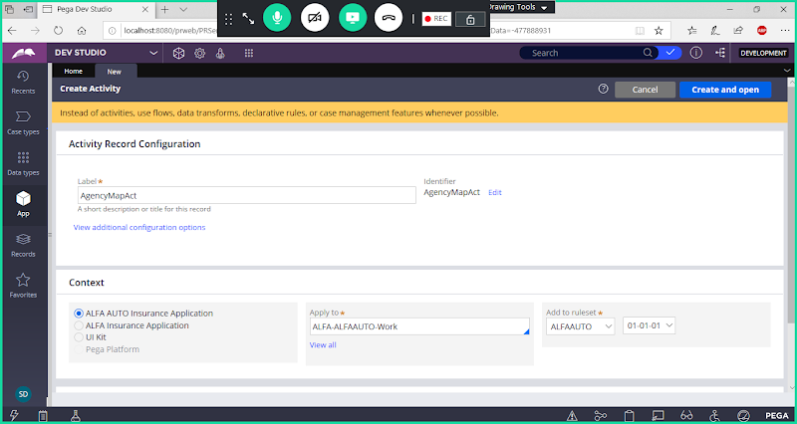

**Open & Go to Security Tab:**

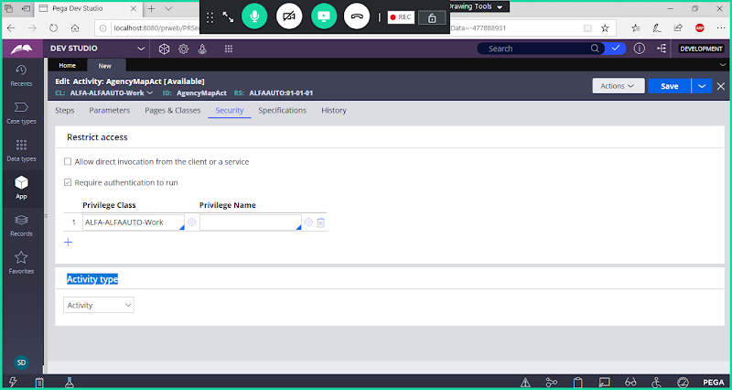

**Change Activity Type : Onchange**

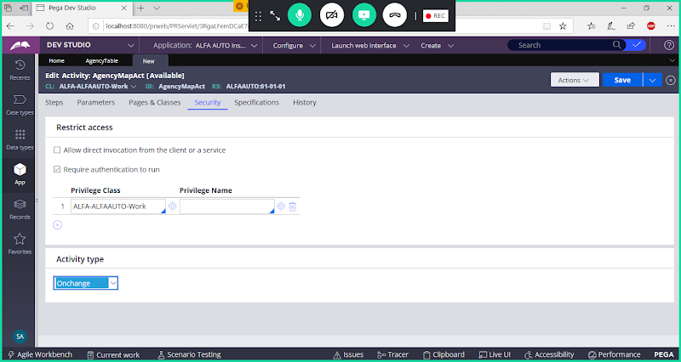

**Go to Steps Tab:**

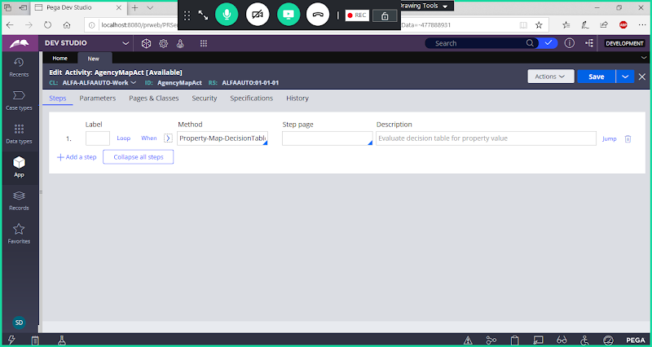

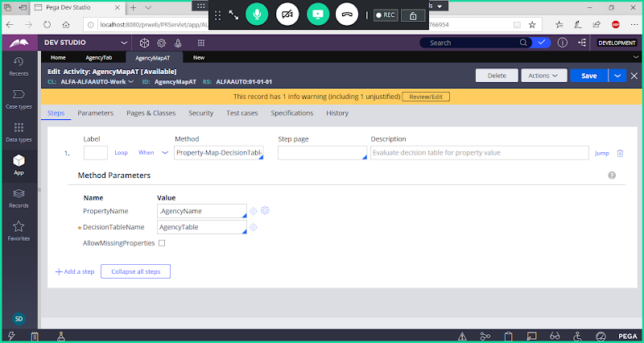

**Save Activity**

**Call Activity in Declare On change Rule:**

**Add Declare Onchange:**

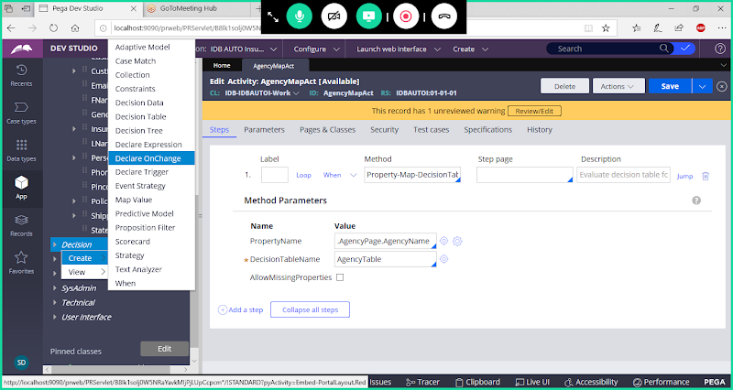

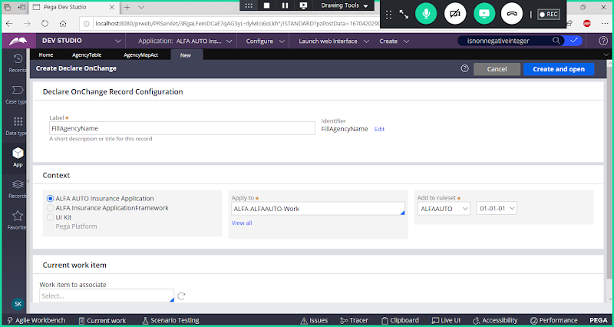

**open**

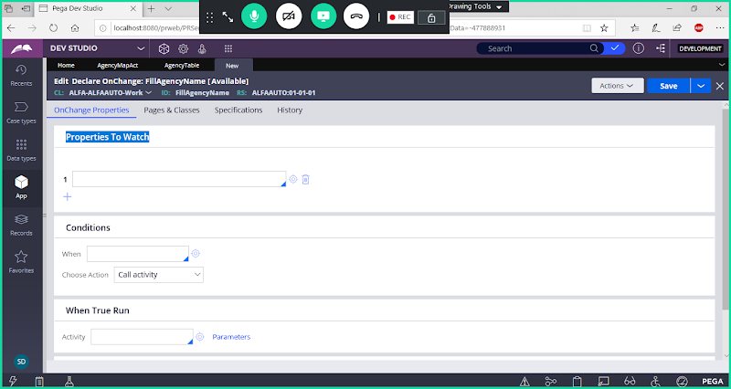

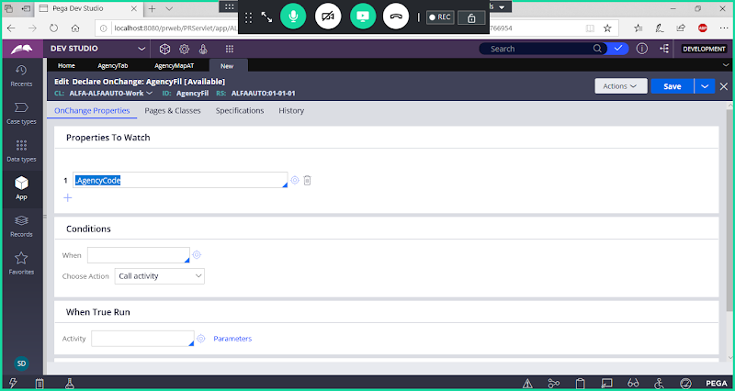

**Now Add Activity When True Run:**

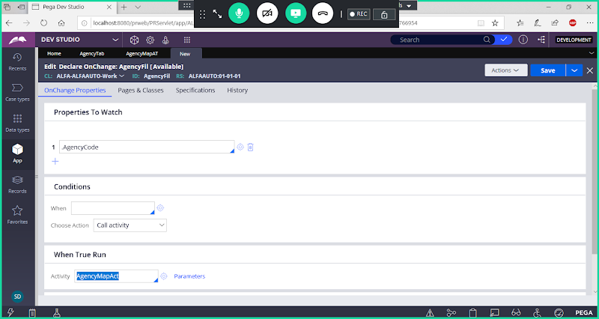

**Save Onchange**

**Set Event & Action for Agency Code Property:**

**Open Agency Section:**

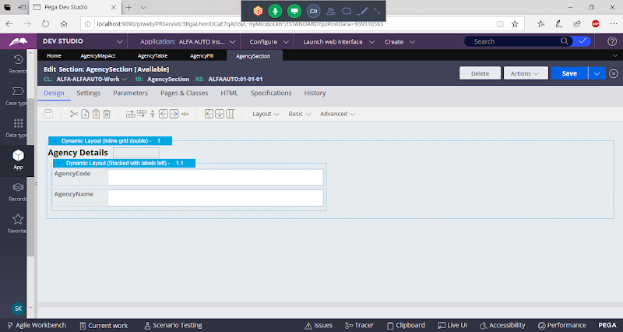

**Double Click on Agency Code:**

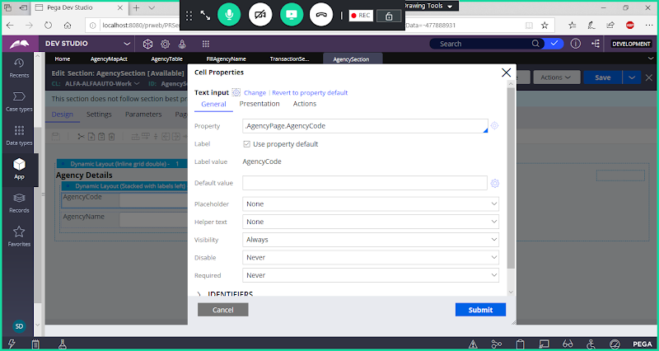

**Event Type: Change**

**Action Name: Display Refresh**

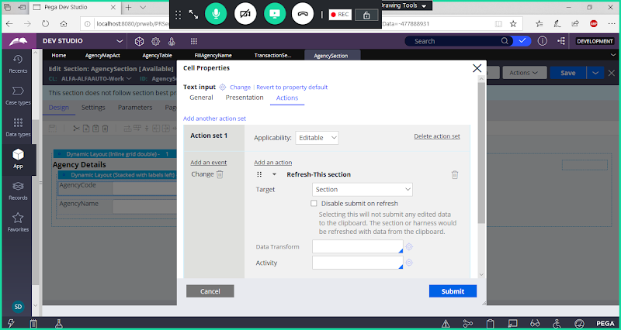

**Submit**

**Set Agency Name as Read Only Field:**

**Double click on Agency Name**

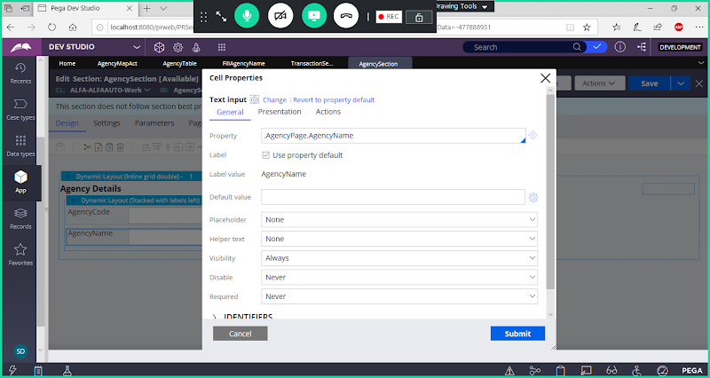

**Go to Presentation**

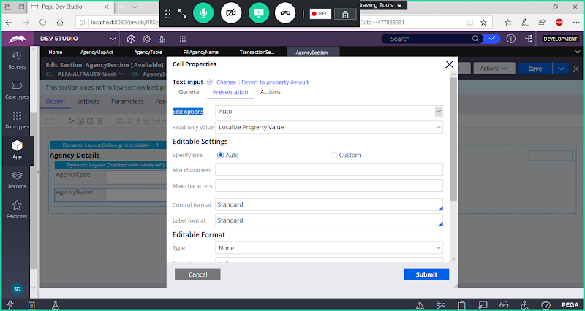

**Under edit options -> Select Read Only Always**

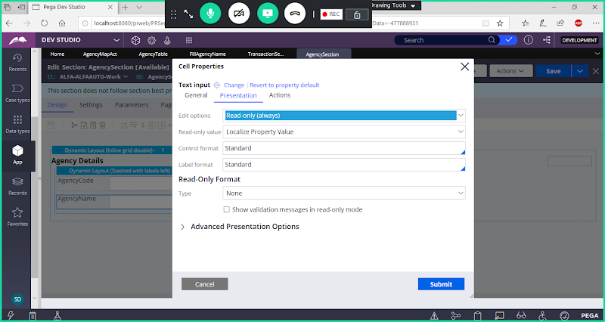

**Submit**

**Save section**

**Now Run Insurance Flow to test the condition, by giving Agency Code Value.**

**Give Agency Code Value**

**How to Block Executing the Constraint Rules:**

**Open Constraints Rule:**

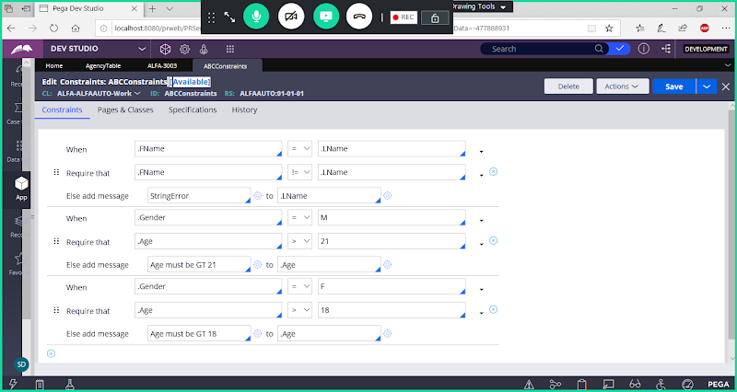

**Under Availability Types Select ( WithDrawn)**

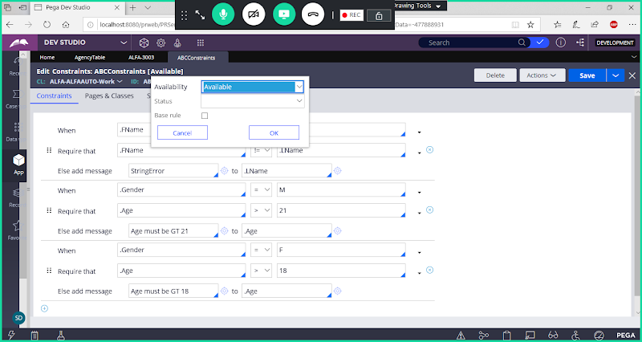

**Select WithDrawn**

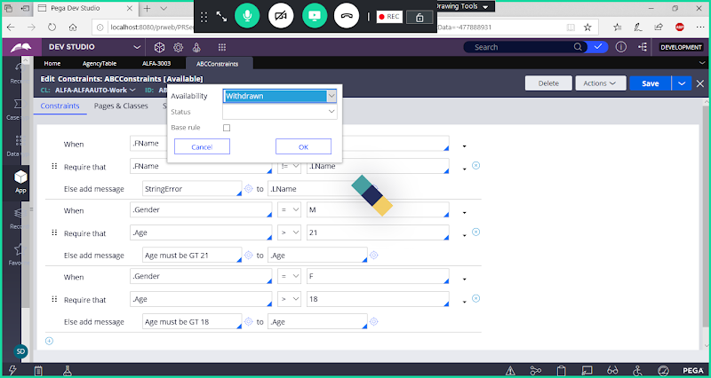

**Click on Ok**

**How to Block Validating OBJ-Validate Rule:**

**Open CustomerDetails FA**

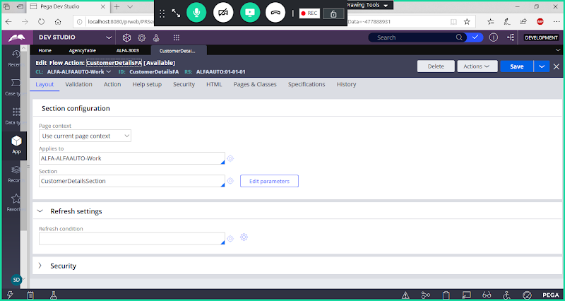

**Go to Validation tab:**

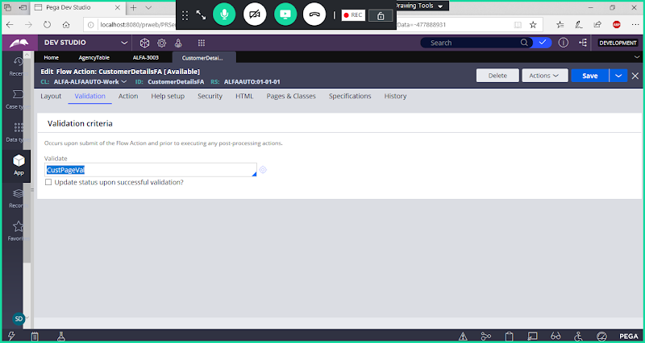

**Remove Validation Name**

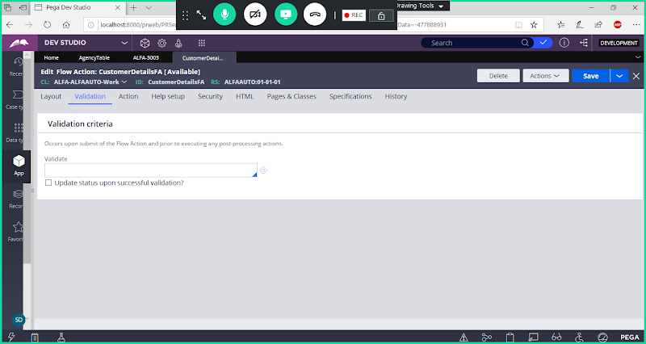

**Save**

**How to Block Edit Validate Rule:**

**Open Age Property**

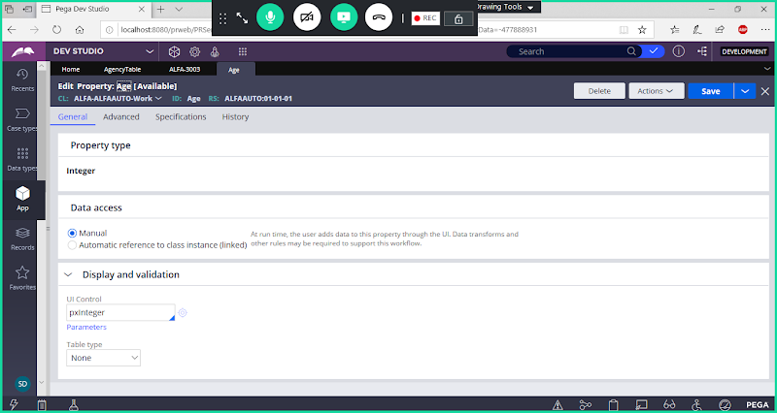

**Go to Advanced Tab:**

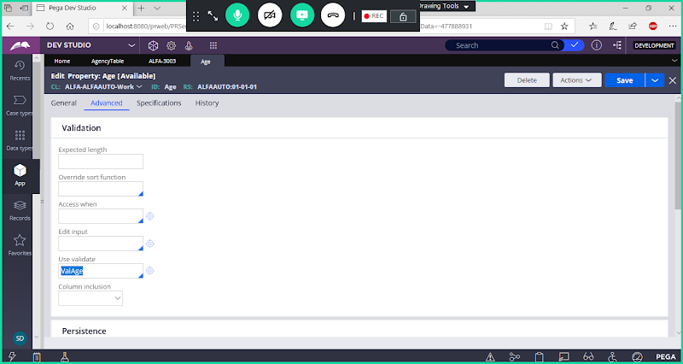

**Remove Validation Name**

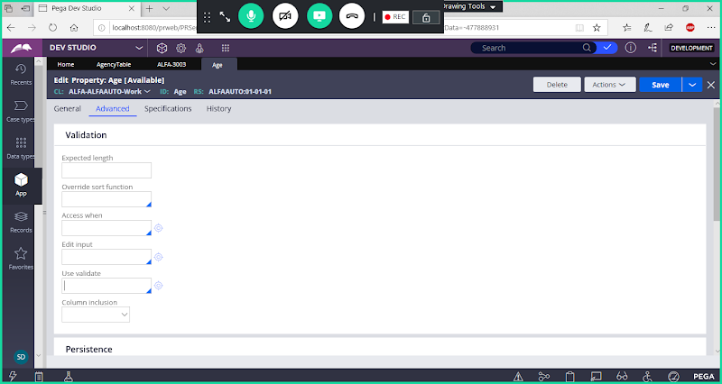

**Save**

**Run Insurance Flow**

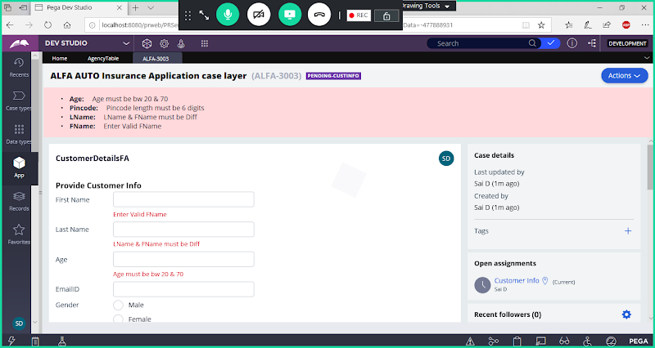

**Now Refresh Work Object Page after Blocking Validation Rules**

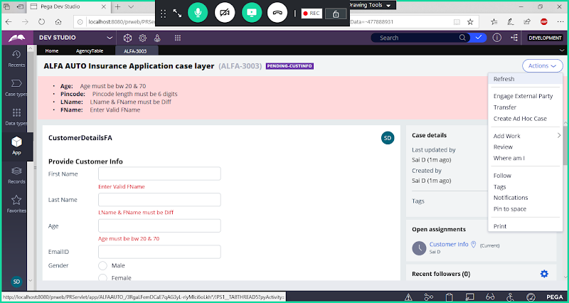

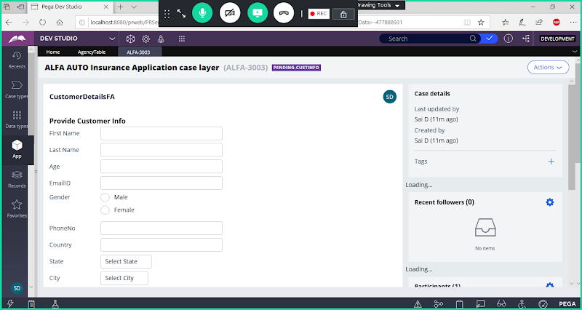

**Submit**

